Template: Nursing Standardized Procedure for Use of Statins in Management of Patients at High Risk for Cardiovascular Events

Clinical Protocol: Nurse co-management of patients receiving treatment of blood cholesterol to reduce atherosclerotic cardiovascular risk

Effective date:
Policy & Procedure:
Revision date:
Last reviewed:

Policy
It is the policy of ________ Health Center to allow qualified RNs (Registered Nurse) to co-manage patients ages 21-75 years at high risk for cardiovascular events with statins (HMG-CoA reductase inhibitors).

I. Procedure

- Functions the RN (Registered Nurse) may perform: collect subjective data (patient history), collect objective data (perform physical examinations), assess patient status, order, and interpret labs, develop, and implement treatment and educational plan of care
- Scope - under the following circumstances, the RN may function:
- Setting – within the clinic site(s)
- Supervision – the RN may operate independently within the constraints and criteria of this policy in partnership with mentoring physician(s) and the designated primary care provider to administer care under the protocol.
- Treatment criteria are based on the 2018 ACC Guidelines treatment benefit groups:
  - Patients with clinical ASCVD (Atherosclerotic cardiovascular disease)
  - Patients with diabetes age 40-75y with LDL >70mg/dL
  - Patients >21y with LDL >190mg/dL
  - Patients with a 10-year ASCVD risk >7.5%
- Additionally, the following criteria must be met:
  - The patient must have a designated primary care provider
  - The patient does not have contraindications for statin medication use See Appendix 2
  - The patient does not have secondary causes of hyperlipidemia: hypothyroidism, hyperglycemia, renal disease, excessive alcohol intake, and/or cholestatic liver disease
  - The patient’s baseline labs are within normal limits: creatinine (Cr) or estimated Glomerular Filtration Rate (eGFR) and transaminase (ALT)
  - The nurse has introduced her/himself utilizing correct title and explain role and the patient accepts RN co-management
- Definitions
- Atherosclerotic cardiovascular disease (ASCVD) – defined as previous heart attack, stroke (CVA), transient ischemic attack (TIA), previous abdominal aortic aneurysm (AAA or ‘triple A’) repair, known coronary artery disease (CAD), peripheral arterial disease (PAD)
- Champion – primary care mentoring physician
- Procedure for Nurse Practice
- Subjective assessment
- Review relevant health history reported by the patient and documented in the Electronic Health Record (EHR) for possible contraindications to statin use
- Conduct a review of systems and evaluate current medications for contraindications to statin use
- Assess health habits: diet, exercise, alcohol intake, and tobacco use
- Objective assessment
- BP (Blood Pressure) measurement
- Lab review:
  - Low Density Lipid (LDL). Consult provider if LDL-C >190mg/dL or TG >mg/dL to evaluate for secondary causes of hyperlipidemia.
  - Baseline or most recent Complete Metabolic Panel with Cr or eGFR and ALT. Consult provider if ALT or AST >3 times upper limits of normal.
  - Hemoglobin A1c
- Assessment – Determine risk for cardiovascular event by history, laboratory and/or ASCVD Risk Estimator Plus calculator.
- Plan
  - All patients should be educated on:
    - Healthy lifestyle:
      - Physical activity (30 minutes per day or 150 minutes a week)
      - Weight management (goal BMI (Body Mass Index) < 25 kg/m²)
      - Dietary choices – select foods low in saturated fats, high in mono and Polyunsaturated fats and fiber
      - Limiting alcohol consumption (<1 drink/day for women; <2 drinks for men)
      - Smoking cessation
    - ASCVD risk
    - Medication risks, benefits, side effects, and administration (timing, cautions)
  - Secondary Prevention (patients with known ASCVD) See Appendix 1
    - Verify and document contraceptive use status for patients who could become pregnant
    - Start HIGH intensity statin with a goal of reducing LDL by 50%. Atorvastatin 80mg, take one by mouth each night. Send 90-day supply to pharmacy. Other high intensity statins may be substituted if formulary, patient preference or tolerance issues occur. See Appendix 2
    - If the highest dose is not tolerated, then reduce to moderate intensity.
  - Primary Prevention (Patients with LDL > 190 mg/dL, patients with diabetes and LDL >70mg/dL, and patients with a 10-year ASCVD risk >7.5% using the ASCVD Risk Estimator Plus calculator). See Appendix 1
    - Patients with LDL > 190 mg/dL
      - Verify and document contraceptive use status for patients who could become pregnant.
      - Start HIGH intensity statin with a goal of reducing LDL by 50%. Atorvastatin 80 mg, take one by mouth each night. Send 90-day supply to pharmacy. Other high intensity statins may be substituted if formulary, patient preference or tolerance issues occur. See Appendix 2
      - If the highest dose is not tolerated, then reduce to moderate intensity.
    - Patients with diabetes and LDL >70mg/dL, and patients with a 10-year ASCVD risk >20% using the ASCVD Risk Estimator Plus calculator
      - Verify and document contraceptive use status for patients who could become pregnant
      - Start MODERATE intensity statin with a goal of reducing LDL by 50%. Atorvastatin 20 mg, take one by mouth each night. Send 90-day supply to pharmacy. Other moderate intensity statins may be substituted if formulary, patient preference or tolerance issues occur. See Appendix 2
      - If the dose is not tolerated, then reduce to lower intensity
    - Patients with a 10-year ASCVD risk Between 7.5% and 19.9% using the ASCVD Risk Estimator Plus calculator
      - Assess for risk enhancers – If the patient has risk enhancing factors, continue to #2-4 otherwise, provide healthy lifestyle education and follow up with their primary care provider.
        - Family history of premature ASCVD
        - Persistently elevated LDL-C ≥160 mg/dL
        - Chronic kidney disease
        - Metabolic syndrome
        - Conditions specific to women (history of preeclampsia, premature menopause)
        - Inflammatory diseases (rheumatoid arthritis, psoriasis, HIV)
        - Ethnicity factors (South Asian ancestry)
      - Verify and document contraceptive use status for patients who could become pregnant.
      - Start MODERATE intensity statin with a goal of reducing LDL by 50%. Atorvastatin 20 mg, take one by mouth each night. Send 90-day supply to pharmacy. Other moderate intensity statins may be substituted if formulary, patient preference or tolerance issues occur. See Appendix 2
      - If the dose is not tolerated, then reduce to lower intensity.
  - Consult the supervising provider if:
    - Possible contraindications or medication side effects. See Appendix 3
    - Evaluating benefits, risks, and patient preferences in treating individuals under 40 years of age.
    - Patients with diabetes and LDL 70-189mg/dL and a ASCVD risk >7.5% using ASCVD Risk Estimator Plus as they may require a higher intensity treatment.
- Patient follow-up
- Order CMP and Lipid panel if not done in last 12 months.
- LDL monitoring is optional to assist with adherence assessment.
  - Check lipid panel 6 weeks after initiation of statin therapy; then every 12 months.
  - Consider lower statin dose if LDL<40 on two consecutive occasions.
  - In individuals with less than anticipated therapeutic response or intolerant of recommended intensity, evaluate, and reinforce lifestyle changes, medication adherence; consult provider to exclude secondary causes of hyperlipidemia.
- If a patient is assessed to have side effects from statin use, nurses will consult a provider to evaluate the patient See Appendix 3
- Record keeping of patient encounters – all patient care (medications, lab work, and education) and verbal or telephone communications with the clinician, or patient/family are documented in the EHR.

II. Requirements for Registered Nurse

A. Preparation
- Education/Licensure: nurse must be licensed as Registered Nurse in California and be in good standing with the Board of Registered Nursing (BRN).
- Experience: a minimum of one year’s experience (full-time or 2080 hours) as an RN is required.
- Training: nurses must successfully complete advanced training on subjective and objective evaluation of patients including statin medications, patient education and implementation of the protocol.
- Nurses must demonstrate knowledge of cardiovascular risk assessment and interpreting lipid test results.

B. Evaluation
Initial: Three cases must be documented and reviewed with Champion each week for one month; followed by 3 cases per month for 3 months; then 6 cases per year. Nurses must demonstrate appropriate management of patients on statins. If the primary care provider disagrees with the management plan, cases will be reviewed with Champion. Evidence of successful completion will be documented and included in the nurse’s personnel file.
Ongoing Evaluation: Annual competency evaluations will be conducted documenting the RNs ability to function appropriately under the protocol including clinical knowledge, skills/ procedures, appropriate consultation, and documentation.

C. Supervision and Review
Roles and responsibilities of Registered Nurses working under the protocol:
- The RN must verify that patients have a designated primary care provider and that the patient meets the criteria for standardized procedure.
- The RN will collaborate and work in partnership with the mentoring provider(s) and the individual patient’s primary care provider to provide care under the protocol.
- The RN will introduce themselves utilizing correct title and explain their role.
- The RN will collect subjective data (patient history), collect objective data (perform physical examinations), assess patient status, order, and interpret labs, develop, and implement a treatment and educational plan of care.
- The RN will maintain record of patient encounters (in person, group, telephone) patient ID, complaints, assessment of adherence to meds, diet, exercise, pertinent lab results, plan for med changes, follow-up labs and visits; primary care provider notification if needed.

Roles and responsibilities of the Champion & the primary care physician:
- Champions should be identified for each site.
- The Champion will assure a provider will be available when the nurse consultation or for the physician to see the patient, the patient requests to see the physician, and/or there is an onsite emergency.
- The primary care provider is responsible for patient management. They will be available for consultation and collaboration with the RN.
- The provider will see the patient or review each patient's care at least once a year and renew the patient-specific medication order annually.

III. Development and Approval of the Standardized Procedure

A. Method – this procedure was developed using the most current guidance from the Board of Registered Nursing, American Academy of Family Practice, and technical references from the PHASE (Preventing Heart Attacks and Strokes Everyday) program.

B. Review schedule – the procedure shall be assessed at 3- and 6-months following implementation and then annually.

References

Grundy S, Stone N, Bailey A, et al. 2018. AHA/ACC/AACVPR/AAPA/ABC/ACPM/ADA/AGS/APhA/ASPC/NLA/PCNA Guideline on the Management of Blood Cholesterol. J Am Coll Cardiol. 2019 Jun, 73 (24) e285–e350.https://doi.org/10.1016/j.jacc.2018.11.003

U.S. Preventive Services Task Force. Statin Use for the Primary Prevention of Cardiovascular Disease in Adults. JAMA. 2022; August 23/30, Vol.328, No.8.

Appendix 1

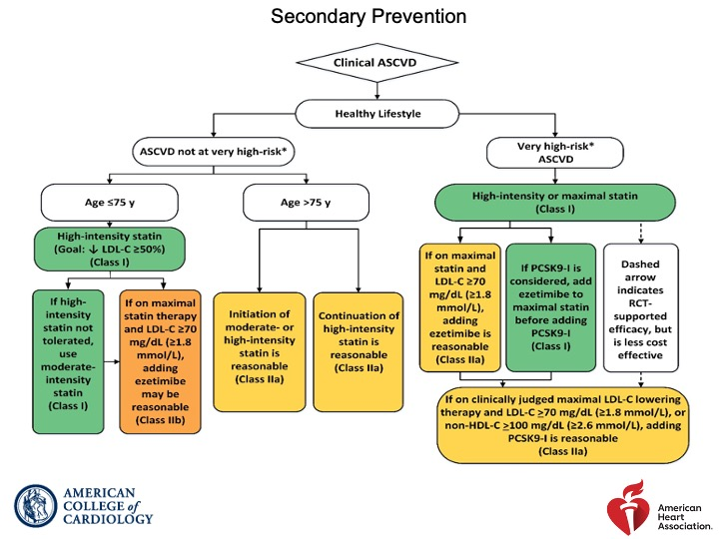

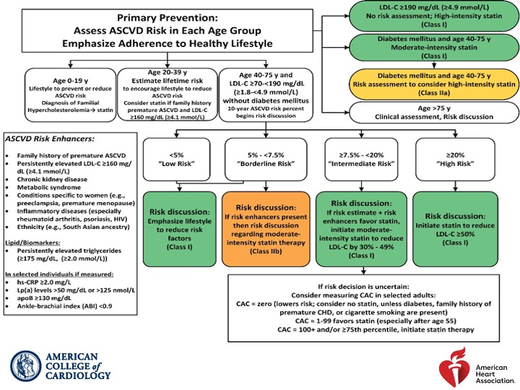

Appendix 2

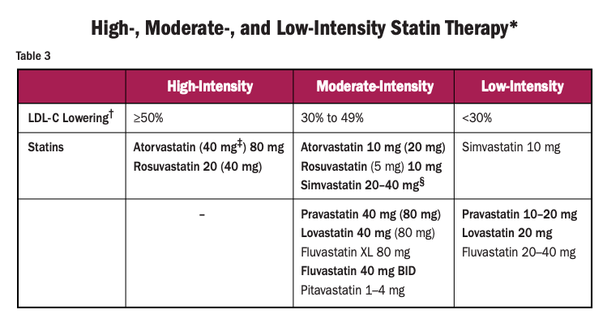

Appendix 3

Contraindications to statins
- History of rhabdomyolysis with prior use or intolerance
- Pregnancy or intended pregnancy
- Lactation

Relative contraindications to statins - consult with provider prior to medication start; may modify decision to use higher statin intensities:
- Multiple or serious comorbidities including impaired renal or hepatic function
- Amyelotropic Lateral Sclerosis (Lou Gehrig’s Disease), other myositis such as polymyositis, inclusion body myositis, dermatomyositis, or uncontrolled hypothyroidism
- Childbearing age without effective contraception
- If prescribing Rosuvastatin and the patient has Asian ancestry

Drug interactions – consult with provider before prescribing if:
- Currently taking anti-viral or antifungal medications fibrate (e.g., gemfibrozil, fenofibrate)
- Currently taking an SSRI medication and/or amlodipine AND considering starting or continuing simvastatin

Medication side effects - If the patient is assessed to have side effects from statin use, the nurse is to consult with the provider

- Myopathy and myalgias: symptoms include muscle ache, muscle weakness, muscle inflammation; very rarely rhabdomyolysis
- Hepatic dysfunction: Jaundice, nausea, fatigue, loss of appetite
- Transaminitis – elevation in AST and ALT over 3 times upper limits of normal
- If the patient experiences side effects, the nurse may decrease the dose to moderate intensity and repeat CMP in 2-3 months after consult with a provider

