**Tobacco Use: Screening and Cessation (NQF 0028 / CMS eCQM 138v6)**

*Percentage of patients aged 18 years and older who were screened for tobacco use one or more times within 12 months AND who received cessation counseling intervention if identified as a tobacco user.*

**Screening for Tobacco Use**

1. From the patient’s progress note, select the  dropdown, then scroll down and select Tobacco Control

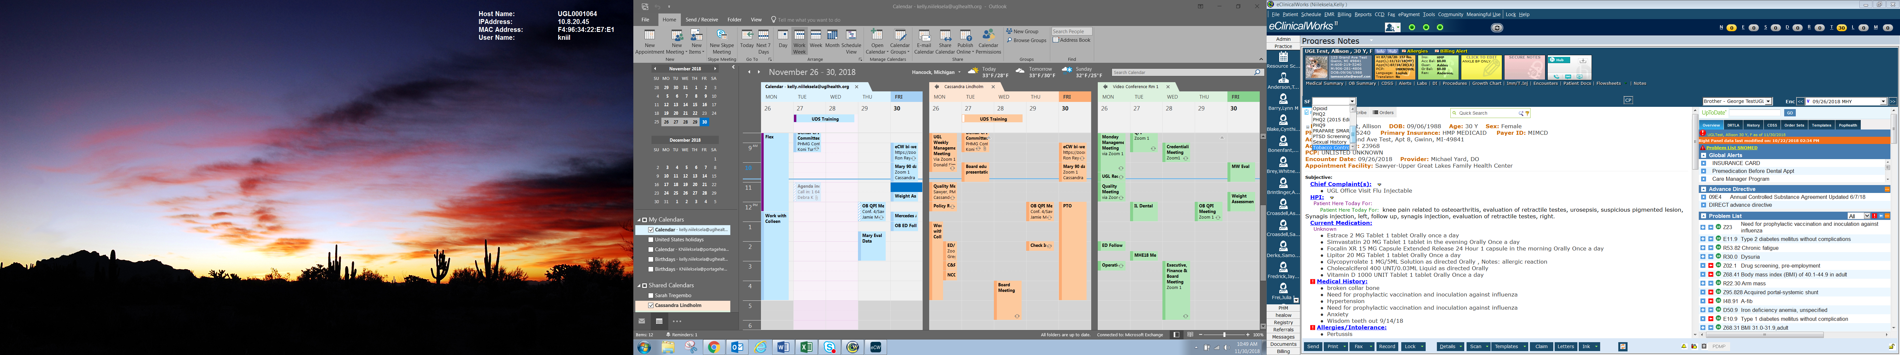

1. The Tobacco smart form has many possible findings to document, but be sure to answer at least one of the top 3 questions (current smoker, former smoker, nonsmoker). Depending on your answers, you will be prompted to answer additional questions.
   1. For smokeless tobacco users, select ‘Uses tobacco in other forms’

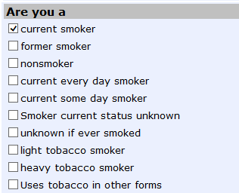

Select at least 1

Optional findings

1. Select any applicable additional findings

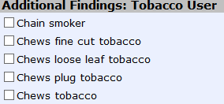

1. Select 
2. The Tobacco Use smart form drops onto the progress note under 

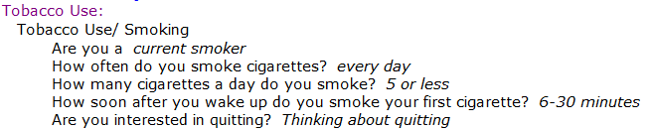

**Documenting Tobacco Use Cessation/Counseling**

If the patient is listed as a ‘current smoker’, there are several ways to document tobacco cessation and counseling. Each category below will illustrate each way to document based on your clinical decision.

**Tobacco Use Cessation Counseling**

1. Tobacco Cessation counseling is captured using ICD codes. To add an ICD code, select 
2. Type Z71.6 in the smart search field
3. Select  or hit Enter
4. Select ‘Encounter for tobacco use cessation counseling’

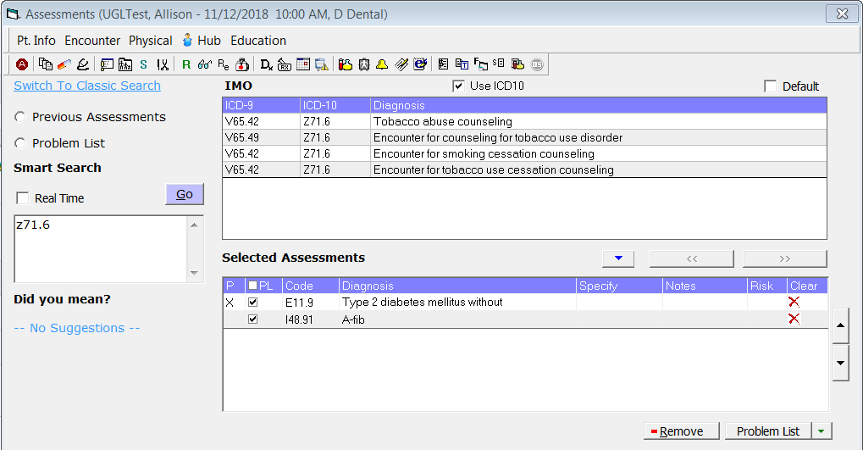

1. The Assessment code drops into the progress note

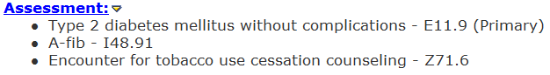

1. Select 
2. Select the ‘Encounter for Tobacco use…’ tab at the top of the treatment window
3. Type a short narrative in the  section of the treatment window on your tobacco counseling discussion with the patient.
4. Include the following in your discussion note
   1. *Advised to quit and impact of smoking*
   2. *Assessed willingness to attempt to quit*
   3. *Providing methods and skills for cessation*
   4. *Medication management of smoking cessation drugs*
   5. *Resources provided*
   6. *Setting quit date*
   7. *Amount of time spent counseling patient*

*Example of Documented Cessation Counseling*

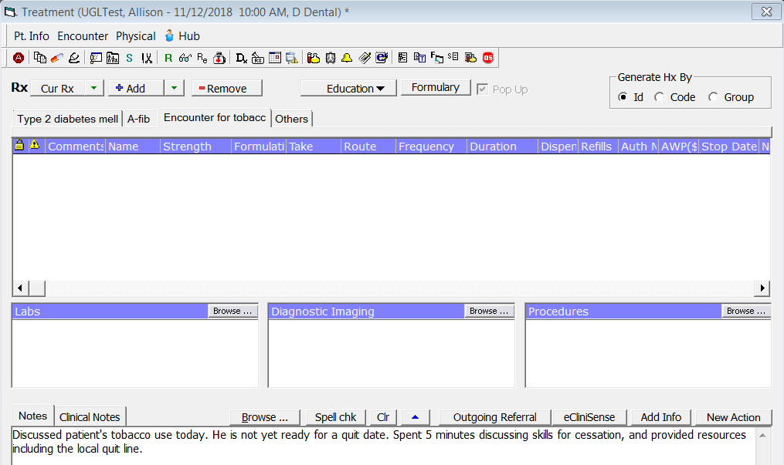

Short Narrative Documentation

**Tobacco Use Cessation – Pharmacotherapy**

A patient will be compliant in Tobacco Use Cessation by prescribing an appropriate medication for tobacco cessation.

1. Select 
2. Choose an appropriate ICD code to prescribe the medication under

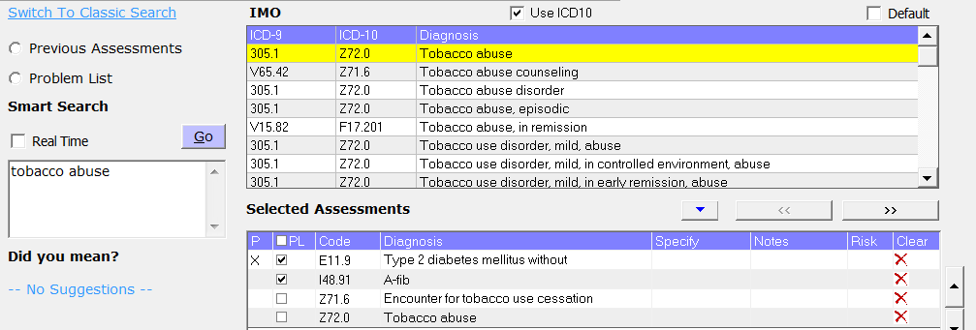

1. Select 
2. Select the tab corresponding to the tobacco use assessment chosen in step 2
3. On the Rx selection menu, select Add



1. Type an appropriate medication in the Find field then select the medication and strength to prescribe

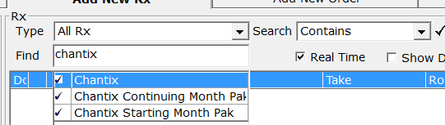

1. Send the Rx in for the patient.

**Tobacco Cessation/Counseling is Complete**