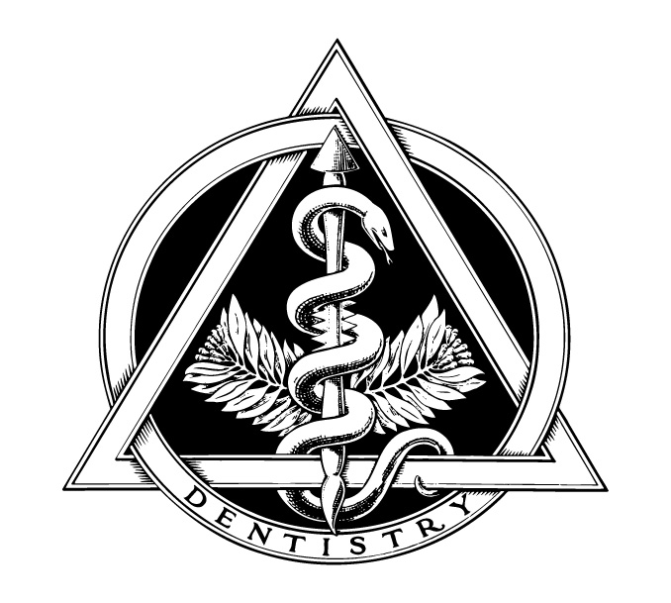

TELE-DENTISTRY TO THE RESCUE DURING COVID 19

The restrictions of practice, social distancing and shortage of PPE created by the COVID 19 pandemic drastically effected access and severed a critical lifeline for our dental patients. Only urgent/emergent dental care was provided in our four dental clinics. Triaging patients suddenly became very important. How do we keep patients out of the clinic and effectively triage only those who need urgent/emergent care? We had heard a lot about tele-medicine but very little about tele-dentistry. Very quickly we developed and implemented tele-dentistry. First, we had to consider the structure of the tele-dental visit which led to the following triage form.

TELE-DENTAL ENCOUNTER SHEET
Phone Call: ___ Video Conference ___ Date _________Time _________ am pm
Patient Name: ______________________________Chart Number: ______________
Tele-dentistry consent reviewed and given: _______

Patient Issue: ________________________________________________________________________________________________________________________________________________________________________________________________________________________________________________________________________________________________________________________________________________________________________________________________________________________________________________________________________________________________________________________________________________________________________________________________________________________________________________________________________________________________________________________________________________________________________________________________________________________________________________________________________________________________________________________________________________________________________________________________________________________________________________

Provider Response:
________________________________________________________________________________________________________________________________________________________________________________________________________________________________________________________________________________________________________________________________________________________________________________________________________________________________________________________________________________________________________________________

Patient Disposition:
Referred to: Hilltop ___ Lakewood ___ Milgard ___ Spanaway ___
Appointment to be made after COVID Distancing Order is lifted ____

The patient response was overwhelming. The majority felt less abandoned and expressed relief that we were still available to meet their urgent/emergent needs.

We will continue using tele-dentistry after the COVID crisis. It has been a life-saver for our patients.

