Draft Preliminary D2P Survey Results

*Collected June 2020*

Mid-implementation staff survey to understand where gaps still are in our telehealth workflow for the purpose of providing targeted follow up training. Issues surrounding capturing insurance info.

**Who completed this survey?**

Data as collected from 100% of the staff identified by each Site Director (28 employees who engaged in the D2P scheduling process at their site.) It included 10 Intake Coordinators, 2 BH Care Managers, 2 LPN’s, 6 Medical Assistants, 1 clerical Medical Assistant, 1 MA/Lab, 1 Medical Provider, 1 Nurse, 2 RN’s 1 RN-Nurse Manager, 1 Site Director, RN

|  |  |  |
| --- | --- | --- |
| ***Site*** | ***Number of responses received*** |  |
| ***Ashland*** | 5 |  |
| ***Hardin*** | 3 |  |
| ***Lewistown*** | 2 |  |
| ***Miles City*** | 9 |  |
| ***Sweet*** | 9 |  |
| ***Total Responses*** | 28 |  |

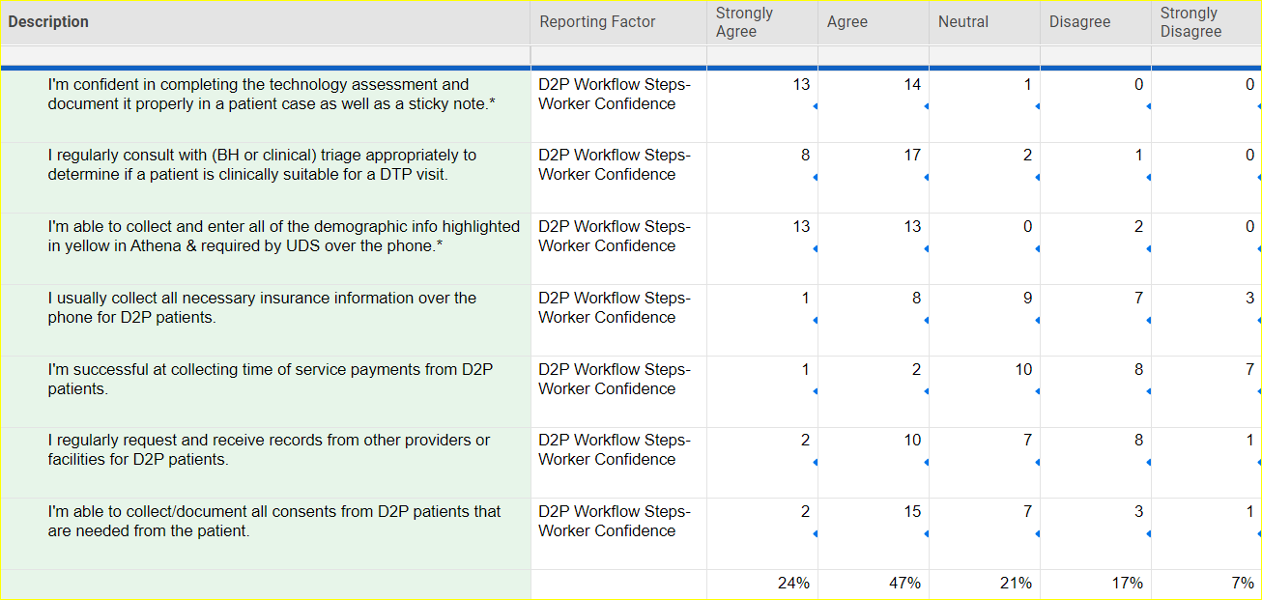

Don’t Know

