**SCHC Dental Emergency Policy for COVID-19**

**Updated 5-6-2020**

On Monday, March 16th Shawnee Christian Healthcare Center Dental Office discontinued routine dental procedures.  Patients with pain and infection will continue to be prioritized pursuant to current [CDC](https://www.cdc.gov/coronavirus/2019-ncov/hcp/dental-settings.html) and [OSHA](https://www.osha.gov/SLTC/covid-19/dentistry.html) recommendations.  Personal Protective Equipment (PPE) is critically low and will be a necessary pre-requisite for resumption of non-emergent and non-urgent care. It is not possible to eliminate all risks. It is possible to employ precautions that mitigate risks and protect our staff and patients. Universal body substance precautions remain as the front line for reasonable risk reduction. However, when dealing with a contagious agent that is spread by droplet contact, we need to recognize the need to manage our generation of aerosols as a prudent additional measure. This protocol seeks to implement additional risk reduction while still maintaining a reasonable level of service for our patients and community. This protocol will be updated frequently as state and national public health information is available.

[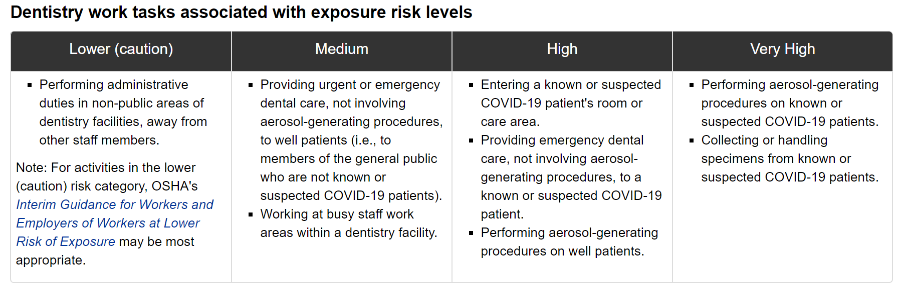](https://www.osha.gov/SLTC/covid-19/dentistry.html)

**Exposure Controls**

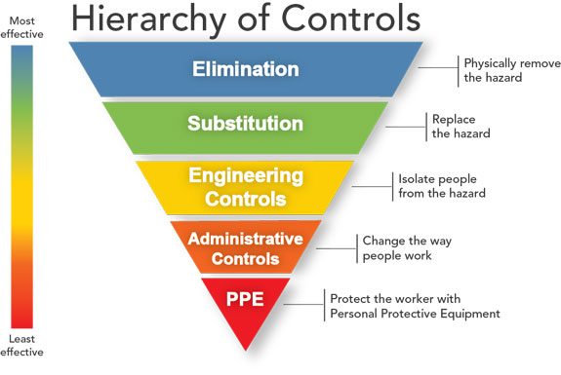

1. Elimination

As COVID-19 has displayed community transmission while asymptomatic, universal precautions must be implemented. OSHA states May 1st, 2020 “Unless emergency dental procedures absolutely cannot be delayed, OSHA further recommends that emergency dental procedures be performed on patients with suspected or confirmed COVID-19 only if appropriate precautions, including personal protective equipment (PPE), are available and used.”

1. Engineering Controls
2. The registration desk will maintain plexiglass barriers in both check-in and check-out areas.
3. Aerosol Generating Procedures (AGPs) will be avoided when possible. When AGPs are necessary for an emergency patient, the designated operatory will be left unavailable for patient treatment after patient dismissal. The room will be sanitized by either the treating dentist, hygienist, or assistant. After sanitation the operatory should be closed for an additional 3 hours before repeated sanitation and seating the subsequent patient.
4. All handpieces (i.e., high- and slow-speed motors, nose cones, contra-angles, motor-to-angle adapters and prophylaxis angles), unless disposable, are heat sterilized between patients.
5. Cleaning, sterilization and maintenance procedures described by the handpiece manufacturer are followed to ensure proper sterilization and maximum longevity for the handpiece. Before removing handpiece from hose the lines are flushed for 20-30 seconds. Handpiece (with the bur removed) is scrubbed thoroughly under running water, rinsed thoroughly, and dried. Cavi-wipes are never to be used on handpieces. Handpiece requiring pre-sterilization lubrication is lubricated using QuattroCare. Handpieces are packaged and sterilized in a steam autoclave.
6. HEPA filtration systems and chairside High Volume Evacuation (HVE) with four handed dentistry will be used for all AGPs
7. Hand sanitizer will be provided in lobby
8. When possible, directional airflow (e.g. fans) will ensure that air flows through staff areas before patient treatment areas
9. All items with high touch frequency shall be removed from waiting room
10. Administrative Controls/Workflow Suggestions – Phone triage and teledentistry screenings should be used when possible. All patients appointing and entering should be asked if they have had the following symptoms:
11. Fever
12. Cough
13. Difficulty holding breath, shortness of breath
14. Lack of Taste/Smell
15. Muscle Aches and/or headache
16. Known exposure to person with COVID-19

Patients reporting yes to any of the above questions should be transferred (phone) or escorted (in-person) to medical for testing/evaluation before dental treatment.

Request patients

1. Wear mask to clinic
2. Leave visitors at home
3. Call upon arrival, when possible

Patients with compromised immune systems and/or present with chronic disease (ASA 2 and above), patients aged 65 and older w/ chronic systemic conditions should be given first appointment of the day ONLY reserved for emergent/urgent care

Aerosol Generating Procedures (AGPs) include handpieces, ultrasonic scalers, and air-water syringes. Prioritize minimally invasive/atraumatic restorative techniques (hand instruments only).

When AGPs cannot be avoided, appropriate precautions should be followed. Minimize the number of staff and family present in the operatory during procedure.

Ultrasonic bath for contaminated instruments must always be covered while in use.

Perform as many tasks as possible in areas away from patients and individuals accompanying patients (e.g., do not remain in a patient care area to perform charting, sterilization, or other tasks).

Workers should avoid touching their faces, including their eyes, noses, and mouths, particularly until after they have thoroughly washed their hands after completing work and/or removing PPE.

Management of Treatment Areas:

* 1. Potentially contaminated aerosols may linger in the treatment room for up to three hours; dental operatories will be sanitized and disinfected in an enhanced manner including:
     1. Personnel must wear recommended PPE to wipe down all surfaces
     2. All cabinets must be closed and any unnecessary equipment/supplies needs to be put away out of potential risk of aerosols
     3. Disinfect all surfaces in treatment areas between each patient and at the end of the business day
  2. Disinfect blood pressure cuff/lead apron/all other equipment needed and replace any plastic barriers

1. Personal Protective Equipment (PPE)

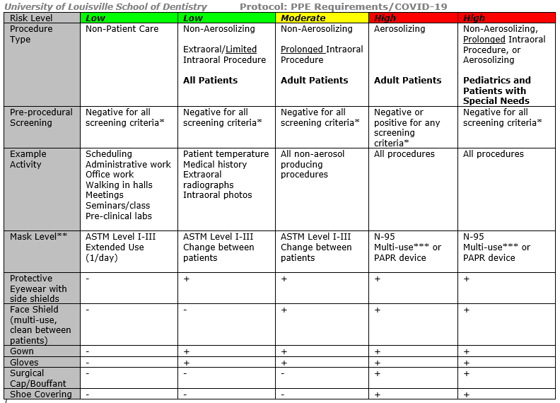

*When possible, order and wait for COVID-19 test results before completing any aerosolizing procedure or non-aerosolizing procedures that involve prolonged intraoral exposure. A negative COVID-19 test is accepted by SCHC for up to 72 hours prior to an aerosol-generating procedure. A COVID-19 positive test would require referral for treatment to ULSD

**Level 1: Low barrier. Designed for procedures with a low amount of fluid, blood, aerosol exposure, or spray. Particle filtration efficiency @ 0.1 micron is >95%. (A COVID-19 virus particle is spherical with an approximate diameter of 0.125 microns.) Resistance to penetration by fluid under pressure is 80 mm Hg.

Level 2: Moderate barrier. Suitable for procedures with a light to moderate amount of blood, fluid, aerosols, or spray. Particle filtration efficiency @ 0.1 micron is >98%. (A COVID-19 virus particle is spherical with an approximate diameter of 0.125 microns.) Resistance to penetration by fluid under pressure is 120 mm Hg.

Level 3: High barrier. Ideal for procedures with a moderate to high amount of blood, fluid, aerosols, or spray. Particle filtration efficiency @ 0.1 micron is >98%. (A COVID-19 virus particle is spherical with an approximate diameter of 0.125 microns.) Resistance to penetration by fluid under pressure is 160 mm Hg.

***When using an N-95 mask for multiple patients, place a regular surgical mask over it. At the conclusion of a procedure, dispose of the regular surgical mask.

In an effort to be compliant with the [Secretary Friedlander’s directive](https://chfs.ky.gov/agencies/dph/covid19/phaseIrollback.pdf) to begin re-opening phase 1 of the economy in dental settings, the following actions will be taken, presuming continued decline of community transmission.

**Phase I April 27th**

1. All dental staff must be screened for temperature and COVID-19 symptoms upon arrival for their shift and this will be recorded and retained. Staff will wash hands before reporting to workstation upon arrival and whenever returning to the clinic from breaks outside.
2. Staff must stay home if sick.
3. All staff will wear a mask for the appropriate task
4. Patients who cannot provide their own mask will be offered one upon entry
5. Temperature and screening will be recorded
6. Request patients use a pre-procedural rinse of 1% hydrogen peroxide before evaluation
7. Patient waiting room chairs will be removed. Patients will be seated directly in their assigned operatory to resume any paperwork and registration.
8. Sanitation will be completed after every entry and exit, clipboard usage, and bathroom entry
9. Door handles, breakrooms, light switches and workstations will be sanitized twice daily, once mid-day and once before close of business.
10. Hand sanitizer will be available in break room, lobby, and all clinical areas
11. HVE will be used chairside during all dental procedures
12. Rotations of DMD, RDH, and dental assisting students are not permitted to return to SCHC during this phase of treating patients
13. 2 weeks of full PPE for full staff must be procured before moving to Phase II
    * 1. One N95 is to be used per day per team member treating patients
      2. Level 3 mask to be placed over top of N95 and replaced PER PATIENT
      3. Face shield to be wiped down after each patient; and to be worn along with gown, goggles, masks – preserve supply as we can
      4. Masks (of some level) at all times will be the standard of this ‘new normal’ for protections against COVID-19
      5. Eventually, (when available,) surgical caps, booties, gloves, masks, gowns are to be disposed of after each patient appointment (especially aerosol-generating appointments)
      6. All dental team members will wear surgical or appropriate procedural mask while in the dental office
      7. In addition to enhanced hand hygiene, dental team members will wear non-latex gloves and change between patients, preferably disposed of in the treatment area in which the gloves were used
14. Visitors are allowed only when necessary for treatment for minors, limited English proficiency, or persons with a disability. (mask, temperature, and screening must be administered)
15. Patients will be called for follow up screening two days after treatment to ensure no new symptoms of COVID-19 have surfaced. Appropriate measures should be taken if symptoms have changed
16. Employees are encouraged to change their clothes at work if possible and to not wear any of the exposed clothing home that they wore in the clinic, including shoes. If not possible, remove shoes at home entrance and wash clothes immediately. Take a shower right away. Consider hair/shoe coverings if aerosol generating procedures must be completed.
17. Create and post laminated educational posters explaining some of the SCHC Dental Office’s changes for our patients
18. Appointment times increased by 15 minutes to allow for additional sanitation and PPE requirements
19. Hair should be pulled back and consider elimination of facial hair. Hair coverings should be used, when available. No makeup will be permitted for clinical staff to preserve the life of the N95.

**Phase II May 25th**

Moving into phase II care requires the following:

* relaxation of national recommendations from OSHA and the CDC
* A HEPA Filtration system ordered and installed
* HVE equipment purchased and assigned to each operatory
* Adequate PPE is acquired for the full staff for two weeks of full volume

1. Lab cases can be resumed, appointing most medically vulnerable patients first opening of the day
2. Comp exam, oral hygiene instructions, FL- varnish for pediatric patients
3. Prophylaxis, Full Mouth Debridement, and Scaling and Root Planing completed only when medically necessary (starting chemo, transplantation, pregnancy, uncontrolled diabetes, etc.)
4. Each patient will be scheduled staggered across all 5 operatories to avoid AGPs. 6 in the morning and 6 in the afternoon during limited staffing requirement
5. Resume intra-oral radiographs and Comprehensive exams with perio probing
6. No air/water syringe is to be used before enhanced aerosol protections are in place
7. All items in operatory which cannot be disinfected shall be removed from operatory or placed in cabinets and drawers

Staffing

1. Cortne, Mathias, Shayaan and Jenesis can be invited to return to work 5/6 with time for training before seeing patients in Phase II 5/25
2. Cathy can report to work for administrative duties 5/18
3. Tasha can report to work 6/1

**Phase III June 15th**

Moving into phase III care requires the following:

* PPE supply chain restored
* Aerosol mitigation equipment installed

1. Appointment times still increased by 15 minutes to allow for additional sanitation and PPE requirements
2. Restorative and surgical procedures resume with HEPA, HVE, and four handed dentistry
3. Routine clinical hygiene resumes with 1 hour appointments for 1 quadrant of SRP and requires HEPA, HVE, and four handed dentistry (Cindy can be invited back to work)
4. Student rotations can resume

All patients wishing to be seen during the pandemic will be offered an additional consent form to be completed for treatment.