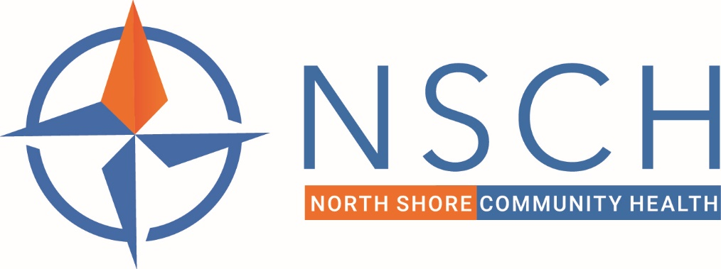

**NSCH PROMISING PRACTICE – PATIENT OUTREACH**

We have made more than 10,610 calls from 3/25/20 to current (that includes most recently 497 calls for SDOH screening to our HSNO patients with 69 SDOH questionnaires administered and 36 CHW referrals).  The outreach on the whole resulted in at least 1379 patient visits scheduled.

The outreach focused on the following groups

Patients with

* uncontrolled HTN
* uncontrolled DM
* CVD
* CHF
* COPD and Asthma

High-ED utilizers (C3)

High-risk for COVID (DRVS and C3 reports)

Patients on warfarin

Patients on depo-provera (transitioned to alternate contraceptives)

Pediatric patients due for immunizations/well child checks

Patients with HSNO for SDOH screening (d/t potential for more barriers to accessing SDOH-related needs among these patients)

Patients who have visited the NSMC ED

Patients with gaps in depression screening especially patients under 18 (SBHC-driven project)

The pediatrics, SDOH, and depression screening are priority areas for outreach currently.

We are also aiming to get going ASAP on colorectal cancer screening outreach (schedule provider visit to review, mail home tests to patients who have care gaps).