Plan-Do-Study-Act Record |  |  | DATE: 5/1/20
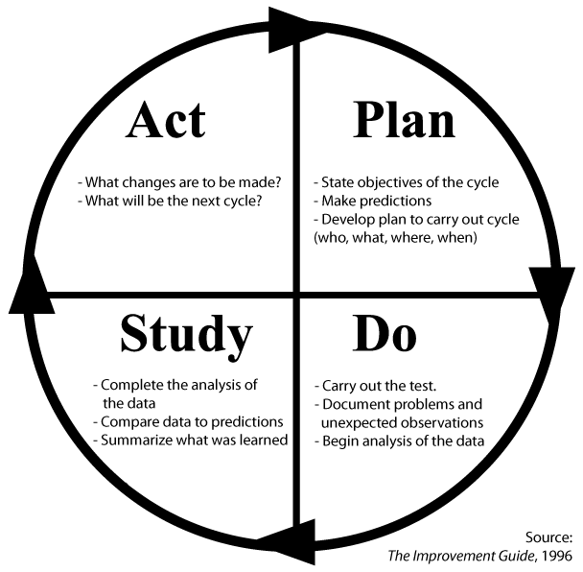 | Change Idea to ____ test or DRIVE THRU A1C TESTING DUE TO COVID____ implement
 | We are initiating a drive through diabetic A1C testing station at our DI , Naranja and MLK sites. Pts who had a visit this year with an A1C >9 or missing were scheduled for a drive through A1C, BP, foot exam and provided a FIT kit if indicated
PLAN
Questions: What do we want to know?
Monitor our patients dx with diabetes to confirm they are in control. Additionally schedule with provider for telehealth visit
Predictions: What do we think will happen? We will increase our compliance with those patients missing an A1C, while increasing telehealth visits and providing patient care during the Public Health Emergency
Plan for Change or Test: who, what, when, where. What are we going to do to make our test happen?
List the tasks necessary to complete this test (what) | Person responsible | When | Where
1. Create list of patients who are missing an A1C or those with an A1C greater than 9 or for those due | AVP PI | 4/24/20
2.  Nursing Staff will contact patients to schedule for drive thru and telehealth appt to follow | Clin Coord | 4/27/20 forward
3.  Signage to be created | AVPVP Comm | 4/27/20 | DI, Naranja, MLK
4. Logistics notified- equipment required: tents, chairs, tables, electrical cord | Dir of Logistics | 5/1/20 | DI, Naranja, MLK
5. Security Notified | Deputy Chief | 5/1/20
6. confirm appropriate supplies | Clin Coord | 4/30
7. confirm appts | Clin Coord | 4/30

Plan for Collection of Data: who, what, when, where. How will we compare predictions to actual?
We will reach a portion of our diabetic population who are in need of an A1C and follow up appt or those that are not in control. This will assist in providing care during this PHE while practicing social distancing and not bringing patients into building

DO: carry out the change or test; collect data and begin analysis; describe the test
The procedure was very successful with 14/19 patients arriving for Doris ison 13/16 for Naranja and 9/16 for MLK. Patients were pleased, staff was pleased and some A1C’s were lowered.

STUDY: complete analysis of data; summarize what was learned.
We learned the following:
- First table (stop) A1C will be initiated since the A1C takes 5 minutes, it can be running while the BP is taken, foot exam is done and FIT kit with instructions are given.
- Create Labels for A1C’s with patient names(to line up )
- Have patient’s turn their car off while at table 2 (stop) for BP, foot exam as to not smell exhaust
- Have trays available with monofiliamint, A1C to bring to car
- Contact patients to confirm prior to appointment and morning or appt with directions
- Extra biohazard bags, FIT kits
- Print health reminders with appt for telehealth written, and due items.

ACT: are we ready to make a change? Plan for the next cycle.
Next A1C drive through scheduled for next Friday 5/8

