MEMORANDUM

TO: Primary Care Associations (PCA)
FROM: NACHC Public Policy and Research Division
DATE: July 30, 2020
RE: State Medicaid COVID-19 Resource Guide

This Resource Guide is intended to assist FQHCs and primary care associations (PCAs) in planning for Medicaid sustainability this year and into 2021. Economic downturns in 2002 and 2009 provide insight into what actions states may take related to their Medicaid programs and the impact on health centers. A number of states are already seeing spikes in Medicaid enrollment and greater pressures on their budgets due to declines in revenue. This Resource Guide focuses on actions and steps that FQHCs and PCAs can take to both protect and enhance the services they provide at a time of tremendous uncertainty among state Medicaid programs.

Key takeaways in this Resource Guide include the following:

- Current federal Medicaid law related to Prospective Payment System (PPS) requirements protects PPS reimbursement for FQHCs services to Medicaid patients from modifications by state governments;
- Federal law protects Medicaid coverage and payment for many optional services under the FQHC benefit, including adult dental services, physical therapy, prescription drugs and rehabilitative services even if the state otherwise eliminates such services;
- However, that protection is not limitless – a state may opt to reduce the amount, duration or scope of the mandatory and optional services they offer; and
- States have taken a range of actions during the pandemic to expand access to Medicaid services – telehealth, eligibility – and many of these policies can and should be codified permanently.

Below is a brief Table of Contents for the Resource Guide:

- Current State Medicaid Landscape (Page 2)
- Medicaid FQHC Services and Payment – Statutory Requirements (Page 2)
- Issues Affecting FQHC Coverage and Payment – Optional Services; Amount, Duration and Scope; FQHC-Specific State Actions; Eligibility Limitations (Page 3)
- Maintaining Pandemic-Related Medicaid Expansions (Page 5)
- Alternative Payment Methodologies (APM) and State Medicaid Budgets (Page 6)
- Talking Points – The Case for Maintaining FQHC Services and Payment (Page 7)
- Medicaid Sample Social Media Graphics (Page 8)

These resources will be updated as more information becomes available and needs are identified. Stakeholders are strongly encouraged to inform NACHC State Affairs (state@nachc.org) of additional resource needs.

Contacts
NACHC State Affairs Department - state@nachc.org
Jeremy Crandall, Director - jcrandall@nachc.org
Susan Sumrell, Deputy Director – ssumrell@nachc.org
Current Landscape

When the pandemic struck, every state in the nation took some type of action to protect their Medicaid programs and providers, many doing so through via Section 1135 emergency waiver authority. Critical provisions enhanced through this authority included substantial expansion of covered telehealth services, higher rates for certain services and expansion of Medicaid eligibility. Additionally, states are also implementing higher managed care payment through state-directed payments from MCOs to FQHCs. When the federally declared emergency expires, it will be critical for PCAs and FQHCs to work with states to protect these improvements. The following statistics underline the urgency of this effort:

- According to the Congressional Budget Office, state budget shortfalls as a result of the pandemic will likely total $650 billion over the next three years.
- The Urban Institute projects an unemployment rate of 15 percent would result in an additional 8-14 million people enrolling in Medicaid.
- Of the 19 states with budget projections available for the upcoming fiscal year, 17 said a Medicaid budget shortfall is “almost certain” or “likely.”
- Following the 2001 Recession (2003-2005), 25 states instituted eligibility restrictions and 36 states made provider payment cuts.
- During the Great Recession (2009-2013), 44 states made provider payment cuts and 18 states eliminated, reduced or restricted non-mandatory benefits, such as dental; physical, occupational and speech therapy; medical supplies/durable medical equipment and personal care benefits.
- Certain states have already begun pursuing reductions to their Medicaid programs:
  - Ohio cut $210 million from the state’s Medicaid budget;
  - Colorado cut $229 million, the vast majority from Medicaid;
  - Alaska cut state Medicaid spending $31 million; and
  - New York Governor Andrew Cuomo sought and had included in the HEROES Act an exception to Medicaid “maintenance of effort” rules, enabling the state to implement new restrictions on eligibility for Medicaid home- and community-based services.

Medicaid FQHC Services and Payment – Statutory Protections

Current federal Medicaid law includes specific protections that ensure FQHCs services are made available to Medicaid patients, and that health centers receive cost-based reimbursement for these services through the Prospective Payment System (PPS), regardless of any actions states take to reduce Medicaid funding. These provisions are specified at:

- Sections 1902(a)(15) and 1902(bb) of the Social Security Act (SSA): Outlines the PPS payment requirements for FQHC services. Section 1902(bb) requires that FQHCs be paid under a prospective payment system (PPS) as described in subsections 1902(bb)(1)-(5) or under an alternative payment methodology (APM) under 1902(bb)(6), the latter of which would have to be agreed to by both the state and the FQHC and could not result in the FQHC being paid less than it would receive under PPS.

- Sections 1905(a)(2)(C), 1905(l)(2)(A) and 1902(a)(10)(A): Defines Medicaid FQHC services and establish them as a mandatory Medicaid service. Included in this definition of FQHC services are Medicare Rural Health Clinic (RHC) services, which are listed in Section 1861(aa)(1) of the SSA and any other ambulatory service provided in the state Medicaid plan. Section 1905(a)(2)(C).
  - Notably, Medicare RHC physician services are defined to include dental services, orthopedic services, podiatry and optometry services. There is legal precedent that holds that by inclusion of these Medicare RHC services in the definition of FQHC services in the Medicaid statute, states must reimburse FQHCs for these services even if they are not in the state‘s Medicaid plan. However, CMS has not issued any guidance that reflects the requirements of that Court decision.

- Section 1937(b)(4): Requires access to FQHC services for low-income adults who were made eligible for Medicaid under the Affordable Care Act in states that have opted to cover them and requires that FQHCs be paid a PPS per-visit rate for those services.

- Section 1903(m)(2)(A)(ix): Requires a Medicaid MCO contracting with an FQHC to serve Medicaid enrollees of the MCO to reimburse the FQHC no less than what the MCO would pay other providers for similar services. Section 1902(bb)(5) requires the state Medicaid agency to pay an FQHC the difference between what the MCO paid the center and what the center would have received under PPS (“wrap-around”).

Issues Affecting FQHC Coverage and Payment

Optional services
It is common for states to drop certain optional services when they seek to curtail Medicaid costs. The following optional services are routinely covered by states, and since they are also “ambulatory,” they would qualify as Medicaid FQHC services. Some of these services may also qualify as a Medicare RHC core service, which must be paid PPS even if the State does not otherwise include the service in the Medicaid state plan. They are:

- Adult dental services;
- Physical therapy and related services;
- Prescription drugs, dentures, and prosthetic devices; and eyeglasses prescribed by a physician skilled in diseases of the eye or by an optometrist;
- Other diagnostic, screening, preventive, and rehabilitative services; and
- Medical care, or any other type of remedial care recognized under State law, furnished by licensed practitioners within the scope of their practice as defined by State law

Reductions in Amount, Duration and Scope
While federal law provides important protections for FQHC services, that protection is not limitless. Rather than eliminating services, a state may opt to reduce the amount, duration or scope of the mandatory and optional services they offer. For example, a state may limit the number of dental, physician or behavioral health visits it will allow per year, place a dollar limit on the value of physical therapy services per year, or limit the number of FQHC visits for a Medicaid recipient. There are limits on a state’s discretion to cut back on services:

- Medicaid regulations require that states provide Medicaid services in “sufficient amount, duration and scope to reasonably achieve their purpose” and prohibit a state from arbitrarily denying or reducing a service to a recipient “because of his/her diagnosis, type of illness or condition.”
- There is considerable case law in which states have been challenged in limiting the amount, duration and scope of a service. Decisions in these cases have not been uniform.
- Controlling case law appears to allow a state to limit a service in amount, duration or scope if the limitation is sufficient to serve the needs of the majority of Medicaid patients who require the service.
- There are a number of additional considerations in determining whether a state’s service limitation is consistent with federal law.
  - For example, a service limitation would appear to be inappropriate when applied to a child who, by virtue of an Early and Periodic Screening, Diagnosis, and Treatment (EPSDT) screen, has been determined to be in need of an (EPSDT) service.
  - CMS may also give states greater flexibility with regard to optional services than mandatory services and for services provided to “medically needy” Medicaid patients rather than for “categorically needy” recipients.

Potential FQHC-Specific State Actions
In addition to the complexities related to optional services, specific areas of vulnerability for FQHCs – where states may take action to reduce Medicaid expenditures – include the following:

- Number of visits per day: Many states currently allow and specify in their Medicaid state plan that a health center may bill more than one FQHC visit per day (i.e. one medical service, one dental service and one behavioral health visit). States may seek to cut back on the number of billable visits per day in order to reduce expenditures. CMS, however, may take the position that changing the number of billable visits per day absent a change of scope in service is not permitted because this results in rebasing the rate.

- Billable visits: State vary on what they treat as an FQHC billable visit. Most states allow centers to bill for face-to-face encounters by so-called “core providers,” including physicians, physician assistants, nurse practitioners, dentists, clinical social workers (CSW), clinical psychologists (CP) and certified nurse midwives. Some states also treat as billable FQHCs visits the services from various other mental health professionals, dental hygienists, dental therapists and other midlevel practitioners. States may decide to limit billable FQHC visits to only core service providers.

- Change in scope of service: Most FQHCs are paid a per visit rate, which can only change due to an increase of the Medicare Economic Index (MEI) or if there is a change in scope of services. States vary in how they define changes in scope of service, how they calculate the cost of the new service, the effective date of the new services, the procedures health centers must follow to request and receive payment for the new service, etc. States may decide to tighten up these various new service definitions and procedures.

- Limiting FQHCs service to the “four walls” of the center: States differ on how they reimburse for services provided outside the FQHC. Many reimburse for services provided outside the center as long as the service is provided by an employee or an individual under contract to the center, if the service is of the type that would be provided inside the center and the person is an established patient. Centers are often reimbursed for services provided at nursing homes, in the patient’s home and in homeless centers. A number of states have expanded the geographic and service range of off-site services during the pandemic, and CMS has approved Section 1135 waivers to many states to allow for expedited implementation of off-site services. States may look to curtail these services and locations, restricting services beyond the four walls of the health center.

Eligibility Limitations
States also have a variety of ways in which they can cut back Medicaid eligibility rules and mechanisms affecting FQHC patients. Cutbacks on Medicaid eligibility will disproportionately impact FQHCs more than other providers since health centers must continue to treat their patients regardless of whether they remain Medicaid eligible or become uninsured. PCAs and FQHCs need to pay close attention to state considerations on eligibility, specifically related to reducing or eliminating the out stationing of eligibility workers at FQHCs and elimination of presumptive eligibility determinations.

Maintaining Pandemic-Related Medicaid Expansions

States have taken a range of actions to address the health care needs of patients during the COVID-19 Public Health Emergency (PHE). Many of these actions will terminate upon expiration of the PHE but could be codified permanently via state legislation or rulemaking. The issues listed below are key examples of expansions states could adopt through regular Medicaid state plan authority and in conformance with managed care rules that otherwise apply outside of the COVID emergency.

FQHC-Specific Measures
- Telehealth: CMS gives states great flexibility on setting their own Medicaid policy. Prior to the pandemic, 38 states allowed Medicaid reimbursement for health centers serving as distant sites, and the reimbursement level varied by state. In March 2020, CMS encouraged states to use telehealth, noting that it will work with states to expedite any needed policy changes.

Today, all 50 states plus the District of Columbia and Puerto Rico have adopted telehealth and audio-only policies during the PHE, the majority of which include FQHCs and are effective through the duration of the PHE. Many are reimbursing at the PPS/APM level, or as they would be paid for in-person visits. However, this policy is not consistent across states, and there is variation on what types of telehealth services are covered and reimbursement rates for these services.

States are beginning to consider how to make these emergency policies permanent. Some states have pursued legislative action to make their pandemic policies permanent, such as Colorado, while others have worked directly with their state Medicaid agencies to add language to their state plan amendment to ensure FQHCs are able to provide and be paid appropriately for telehealth and telephone services. NACHC suggests that FQHCs and PCAs advocate for the following language to be added to a state plan amendment:

“Notwithstanding the previous paragraphs, for services provided via telehealth by FQHCs, payment for such services shall be the same per visit amount that the FQHC would receive for such services if they were provided by the FQHC in a face-to-face visit.”

- Payment of PPS for Services Delivered in Alternate Clinic Locations: Allow FQHCs to bill PPS for services provided outside of the “four walls” of the clinic in alternative physical settings, such as a mobile clinic or temporary location.
- Supplemental FFS and Managed Care Payment: Allow more supplemental payment to reward clinics for improved quality and to help cover the ancillary cost of providing services through telehealth, for example.

Non FQHC-Specific Measures
- Allow self-attestation for all eligibility criteria (excluding citizenship and immigration status) on a case-by-case basis for Medicaid and CHIP eligible individuals subject to a disaster when documentation is not available as outlined at 42 CFR 435.952(c)(3); 42 CFR 457.380.
- Allow presumptive Medicaid eligibility for the Aged, Blind, and Disabled population to the extent this is allowed under current statute and regulation.
- Extend redetermination timelines for current Medicaid enrollees in the state to maintain continuity of coverage as permissible under 42 CFR 435.912(e).
- Waive requirement that State must submit and receive CMS approval of a Title XIX or Title XX state plan amendment in order to temporarily waive any patient cost-sharing associated with COVID-19 screening, testing, and treatment.
- Allow facilities to provide services in alternative settings, such as a temporary shelter or through mobile-units.
- Suspend Medicaid fee-for-service prior authorization requirements.
- Suspend existing cost sharing requirements for all members.

Alternative Payment Methodologies (APM) and State Medicaid Budgets

In the past few years, a number of PCAs and FQHCs have been working with their state Medicaid agencies to develop APMs. The goal of these APMs has been to implement a payment methodology in which FQHCs are reimbursed on a basis other than a PPS face-to-face visit, applying a more value-based approach. Given the anticipated state budget crises, states are likely to increase consideration of APMs.

These APMs – both in managed care and non-managed care – may include per-member-per-month payments (PMPM), payment adjustments to better reflect the behavioral and social determinants of health for the health center patient population, additional payment to the FQHC when quality-of-care metrics have been met and/or financial savings have been realized and payment for other than face-to-face visits such as telehealth. The Medicaid statute and CMS policy allow a state and an FQHC to implement an APM as long as both the state and the FQHC agree to it, the APM does not result in the health center being reimbursed any less than it would under PPS, and the state includes the APM in its state plan through a SPA.

The crisis in health care delivery due to the pandemic provides incentive, opportunity, and the experience of new modes of delivering primary care services that can result in states and FQHCs developing new or revised FQHC APMs. For example, States and PCAs/FQHCs might consider developing an APM for telehealth services. Under an APM, additional payments to the center could be made if certain quality-of care-metrics are met. To support the availability of services in community settings, states could allow centers to receive payment of an APM for services delivered off-site.

PCAs and FQHCs can use the lessons learned during the pandemic to construct service delivery improvements and payment reforms – and move the state away from service and payment cutbacks for FQHCs – that strengthen all of the parties’ ability to better serve the Medicaid population in the future.

Talking Points – The Case for Maintaining FQHC Services and Payment

NACHC has received a number of media inquiries on this issue and developed the following talking points:

- Community health centers are one of the nation’s largest primary care providers for people on Medicaid.
  - On average, 48% of all patients who walk through our doors are on Medicaid.
  - We see 16% of all Medicaid patients while comprising just 2% of total Medicaid spending.

- That means any cuts or reductions to Medicaid, at the state or federal level, has a direct impact on our patients and our health centers’ ability to deliver care.

- We know from our experience in 2002 and 2009 that state Medicaid programs are heavily at risk during economic downturns. Those years provide a roadmap about what actions states may take and the impact on health centers.

- Health centers are unique compared to many other Medicaid providers in terms of how we are funded.

  - A sizable chunk of each center’s resources comes via federal grant funding designed to cover care for the uninsured. It makes centers heavily reliant on Congressional appropriations.
  - The other critical piece is state-based funding. As a leading Medicaid provider, any time a state makes cuts to Medicaid programs, it puts a strain on our patients and a strain on our health centers.

- As we learned during the Great Recession, many states will likely consider reducing or outright eliminating optional Medicaid benefits that our health centers provide.

  - At the top of the list is adult dental services, which are critical to overall health and core services we provide. It also includes behavioral health services; physical, occupational and speech therapy; medical supplies/durable medical equipment; and personal care benefits.

- Our centers pride themselves on providing critical wrap-around care that make the difference in addressing overall health and wellness that most privately insured people already have access to. If these services go away or become prohibitively expensive for our patients, the impact will be enormous.

- Importantly, the impact of benefit cuts is complicated for health centers. Federal law requires states to provide Medicaid payment for FQHC mandated services, but it does not prevent a state from significantly altering the benefits they choose to cover.

  - When these benefits are reduced or no longer covered, that means those services become uninsured services. That means the federal funding we need to keep our doors open increases.

- Looking forward, we are focused on where we can protect the important gains we have made during the COVID-19 pandemic:

  - Improved access to telehealth services; and
  - Section 1115 and 1135 waiver provisions that make it easier for people to enroll in and stay on Medicaid.

- We have great concerns about these impacts on health center patients and health centers as providers – while under great stress from the pandemic and without a solution for our long-term federal funding. These issues only intensify the importance of fair and appropriate Medicaid payments to ensure that health centers are able to provide care to those most in need in their communities.

Medicaid Sample Social Media Graphics
Below are four sample social media graphics for PCAs and Health Center advocates to use in their digital advocacy in support of Medicaid funding. Please feel encouraged to use these images with your organization’s logo or to create your own with similar messaging. Please be sure to tag your state’s Members of Congress and #ValueCHCs. Additional Social Media Graphics can be found in this shared Google Drive. For further support please contact Shamaal Sheppard at ssheppard@nachc.org or the Grassroots Advocacy team at grassroots@nachc.org.

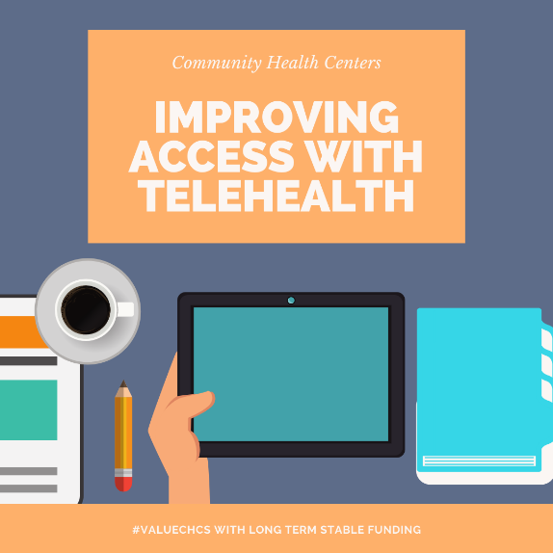
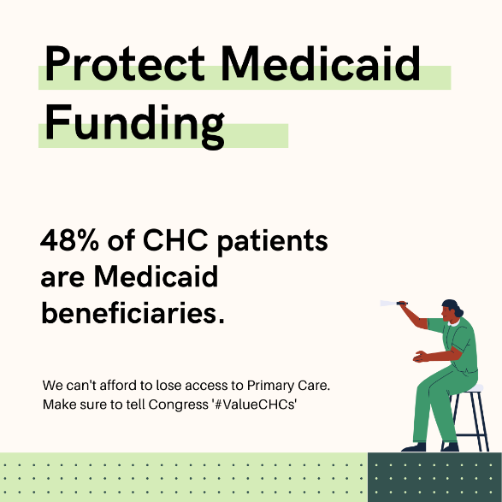

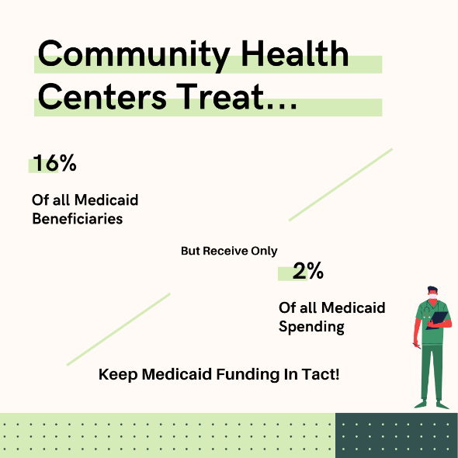

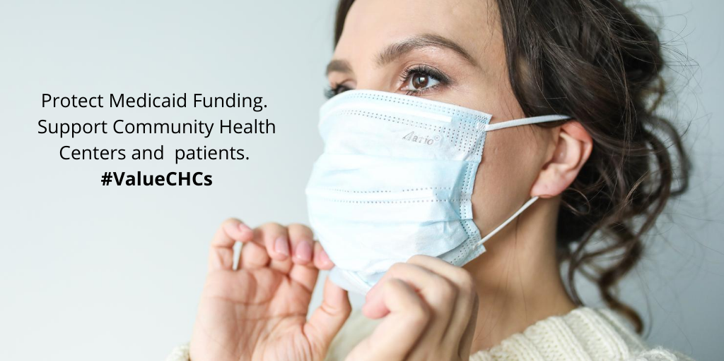

Link to 1135 state plan amendment template: https://www.medicaid.gov/resources-for-states/disaster-response-toolkit/state-plan-flexibilities/index.html
See http://www.nachc.org/focus-areas/policy-matters/medicaid-and-medicare/
These federal citations are to the relevant sections of the Social Security Act (SSA). The same statutory provisions can be found at 42 USC 1396 et al.
Calif. Assoc. of Rural Health Clinics v. Douglas (9th Cir. 7/5/13)
42 CFR 440.230
The examples below are written in the context of FQHC services being provided in non-managed care arrangements, however, these service restrictions would have a similar impact if a health center has contracted with an MCO to serve Medicaid enrollees, as they would likely result in the State or the MCO paying less in wrap-around reimbursement to the FQHC.
Section 1902(bb)(6) of the SSA; and see CMS’ State Health Official Letter #16-006 (April, 26, 2016)

