**Goal:** Reduce potential exposure to COVID-19 for family planning patients, while continuing to provide in-person clinical care when necessary and supporting patients’ desires to prevent pregnancy.

**Contraceptive visits**

1. **Patient desires new method of contraception:** Schedule **PHONE VISIT** and provide contraceptive counseling to identify appropriate and preferred method. May need subsequent **IN-PERSON VISIT** depending on method:
   1. Patient desires prescription for pill/patch/ring:
      1. Screen for contraindications to methods (use CDC Medical Eligibility Criteria). If normal BP documented in the past year, send Rx to pharmacy if appropriate (1 year supply) along with prescription for EC (with refills) and explain when patient would need to use EC and back up condoms.
         1. For patients without documented normal BP in the past year:
            1. Patient with home BP cuff: ask them to take BP and report value
            2. Patients without home BP cuff: advise them to come in for in-person visit after COVID-19 to ensure normal BP. Counsel patient about risks of blood clots and stroke with exogenous estrogen and untreated HTN (risk is quite low, but not zero). If provider determines there is high risk of untreated HTN, consider 3 month Rx rather than longer Rx
         2. For patients with HTN, remember that patient is still likely eligible for progestin-only pill
   2. Patient desires condoms: discuss proper use of condoms. If too expensive to purchase over the counter, Rx to pharmacy
   3. Patient desires fertility awareness: discuss methods, possible helpful apps, and send condoms and EC to pharmacy (with refills) if patient so desires
   4. Patient desires new IUD/implant: schedule **IN-PERSON VISIT**
   5. New DMPA injection:
      1. Schedule **IN-PERSON VISIT** if wants IM injection q 15 weeks
      2. Discuss how to inject SQ and send materials to pharmacy for SQ depo if patient feels able to self administer
2. **Refill of pill/patch/ring/diaphragm:** Send Rx to pharmacy, telephone visit not needed unless patient requests. Ensure patient has Rx for EC (with refills)
3. **IUD/implant placement:** If patient has already discussed with provider, schedule **IN-PERSON VISIT**. If patient has not discussed with provider, schedule **PHONE VISIT** to review and identify appropriate placement timing
4. **IUD/implant removal:** 
   1. Assess reason for removal. If related to symptoms of irregular bleeding, assess interest in management per CDC Selected Practice Recommendations (NSAIDs vs estrogen) before pursuing removal
   2. Discuss with patient whether interested in waiting until after COVID-19 epidemic for removal, while assuring patient that will remove immediately on request
   3. If IUD, discuss with patient if they would like to attempt self-removal and walk patient through how to do this. Should schedule an **IN-PERSON VISIT** for removal if they are unable to remove on their own (or don’t want to try)
   4. Schedule **IN-PERSON VISIT** according to patient preference
5. **IUD/implant removal and replacement:**
   1. Follow recommendations for extended use:
      1. Nexplanon: FDA-approved for 3 years; evidence-based for 5 years[1]
      2. Liletta: FDA-approved for 6 years; evidence-based for 7 years
      3. Mirena (same dose of levonorgestrel as Liletta): FDA-approved for 5 years; evidence-based for 7 years
      4. Skyla: FDA-approved and evidence-based for 3 years
      5. Kyleena: FDA-approved and evidence-based for 5 years
      6. Paragard: FDA-approved for 10 years; evidence-based for 12 (not a hard stop)
   2. If device has reached end of extended use lifetime or there is a clinical reason to replace sooner, proceed with **IN-PERSON VISIT**, advise condoms in the meantime, and consider Rx for CHC (discuss with patient). Consider leaving strings longer if patient is interested in attempting self-removal in the future.
6. **Refill of DMPA:**
7. DMPA lasts for 15 weeks (reschedule patient for **IN-PERSON VISIT** accordingly)
8. Consider scheduling **PHONE VISIT** with SQ DMPA (sent to outside pharmacy) if can be covered by insurance.
9. **Patient desires refill or new Rx for emergency contraception:**
   1. Paragard is the most effective EC; schedule **IN-PERSON VISIT** and discuss pros/cons in time of COVID with patient
   2. Ella is the next best non-Paragard EC option, decreasing effectiveness after BMI 35. Main contraindications are breastfeeding and if patient is going to start a progestin-containing method within 5 days of Ella (that new method will be less effective because of Ella, patient needs to use back-up condoms x7 days, or 14 to be safest)
   3. Plan B is less effective for BMI>26 (and less effective overall as well.)[2]
10. **They have missed pills, or have been vomiting or having diarrhea:**
    1. Pull up your CDC Contraception app (free) and follow the algorithms below
       1. Late or missed doses
       2. Vomiting or severe diarrhea

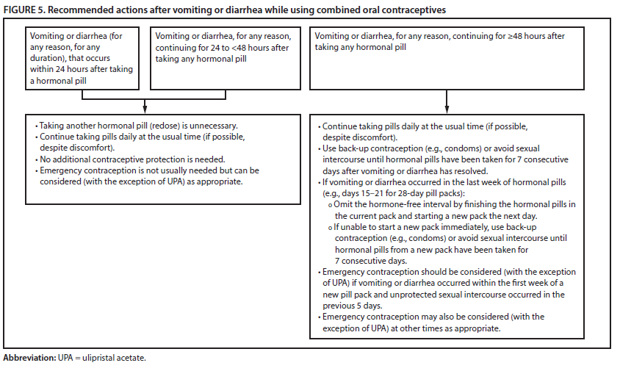

**Non-Contraceptive Gyn Visits** (e.g. annual exams, well woman visits, pap screening)

1. Inquire about contraceptive needs/refills and see section above
2. Review ASCCP interim guidelines for abnormal pap management in this specific COVID-19 setting (published 3/19/20):
   1. Low-grade cytology: postpone diagnostic evaluation up to 6-12 months
   2. High-grade cytology: postpone diagnostic evaluation no more than 3 months. Ensure system to contact patient so not lost to follow up
   3. High-grade cytology without suspected invasive disease: postpone diagnostic evaluation no more than 3 months. Ensure system to contact patient so not lost to follow up
   4. Suspected invasive disease: contact within 2 weeks and evaluation within 2 weeks of that contact (within 4 weeks of the initial report/referral)
3. Reschedule all other visits until after COVID-19 unless deemed clinically urgent (heavy bleeding with symptomatic anemia, pelvic pain suggestive of IUD expulsion, PID, or ectopic pregnancy, etc.)
4. If patient has gynecologic symptoms that are NOT urgent (vaginal discharge) consider providing empiric Rx over the phone and schedule follow up call to assess resolution
5. If patient with dysuria, patient can go directly to lab for urinalysis and GC/CT urine. Can do empiric treatment for compelling history, or wait for lab results
6. STI testing: If patient has new exposure or concerning symptoms, consider ordering lab tests (urine GC/CT, blood tests) and patient can go directly to the lab. If patient requesting routine testing without exposure or symptoms, recommend scheduling visit after COVID-19

**Abortion and Early Pregnancy Loss Visits**

1. Options counseling: Schedule **PHONE VISIT** with OB RN or provider
2. Medication or surgical management of unintended pregnancy: give phone numbers for Planned Parenthood and Cedar River Clinics
3. Medication or surgical management of early pregnancy loss:
   1. **PHONE VISIT** if early pregnancy loss already diagnosed (e.g. at ED with ultrasound or by falling beta hcg levels)
   2. **IN-PERSON VISIT** if early pregnancy loss suspected but not confirmed, or if patient prefers in-person visit to discuss management
   3. Consider medical management with misoprostol Rx by phone (along with other medications for pain/cramping/nausea) if low concern for severe bleeding based on careful ROS by phone. Close telephone follow up with OB RN, triage RNs, or provider and **IN-PERSON VISIT** if any symptoms are severe
   4. If patient desires surgical management (i.e. MVA procedure), refer to Planned Parenthood, Cedar River Clinics, or discuss with Emily Flynn and Glenna Martin for possible MVA procedure at Carolyn Downs

1. McNicholas, C., Swor, E., Wan, L., Peipert, JF. Prolonged use of the etonogestrel implant and levonorgestrel intrauterine device: 2 years beyond Food and Drug Administration-approved duration. [Am J Obstet Gynecol.](https://www.ncbi.nlm.nih.gov/pubmed/clipboard) 2017 Jun;216(6):586.e1-586.e6.
2. [Glasier A, Cameron ST, Blithe D, et al. Can we identify women at risk of pregnancy despite using emergency contraception? Data from randomized trials of ulipristal acetate and levonorgestrel. Feb 2011, 84(2011): 363-367.](http://wcsh.org.uk/sites/wcsh.org.uk/files/Glasier%202011.pdf)